**Expt No 06:**

Create a simple cloud software application for Payroll Processing System using any Cloud Service Provider to demonstrate SaaS include the necessary fields such as Name of the employee, experience in present org , over all experience, basic pay, HRA, DA, TA, net pay, gross pay etc.

**Date:** 22/02/2024

**Aim:**

To Create a simple cloud software application for Payroll Processing System using any Cloud Service Provider to demonstrate SaaS include the necessary fields such as Name of the employee, experience in present org , over all experience, basic pay, HRA, DA, TA, net pay, gross pay etc.

**STEP 01:**

Open a Zoho web application and click a Create a New application and Create a New Component And select a Component Type as Form Type.

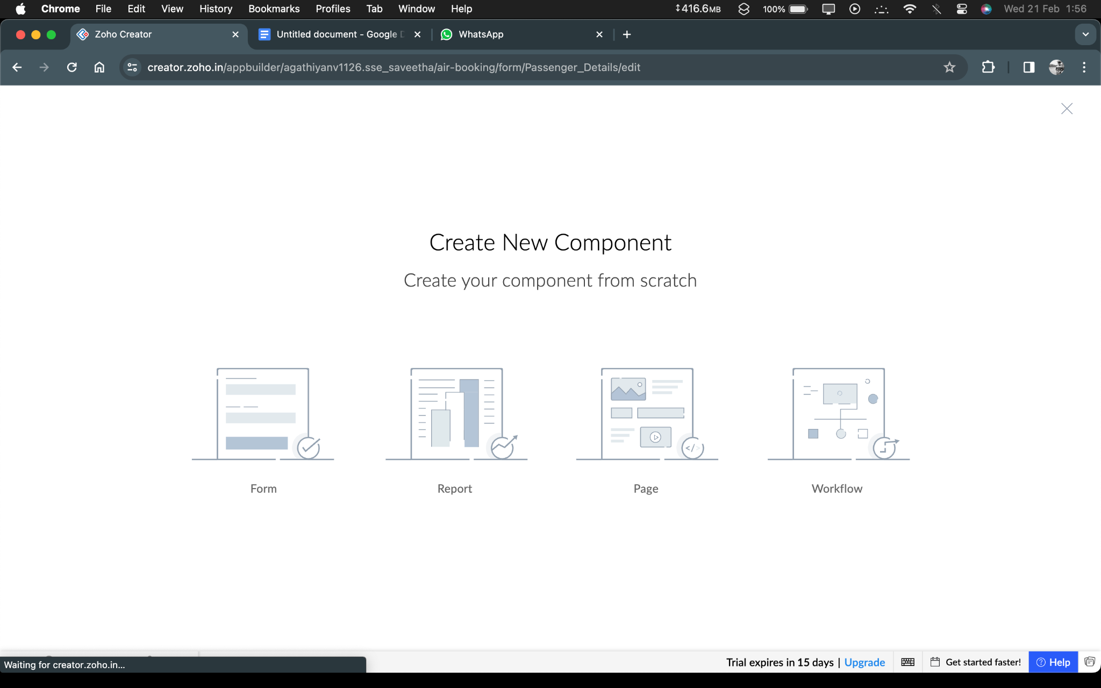

**STEP:02** Start To a Create a Form from Scratch

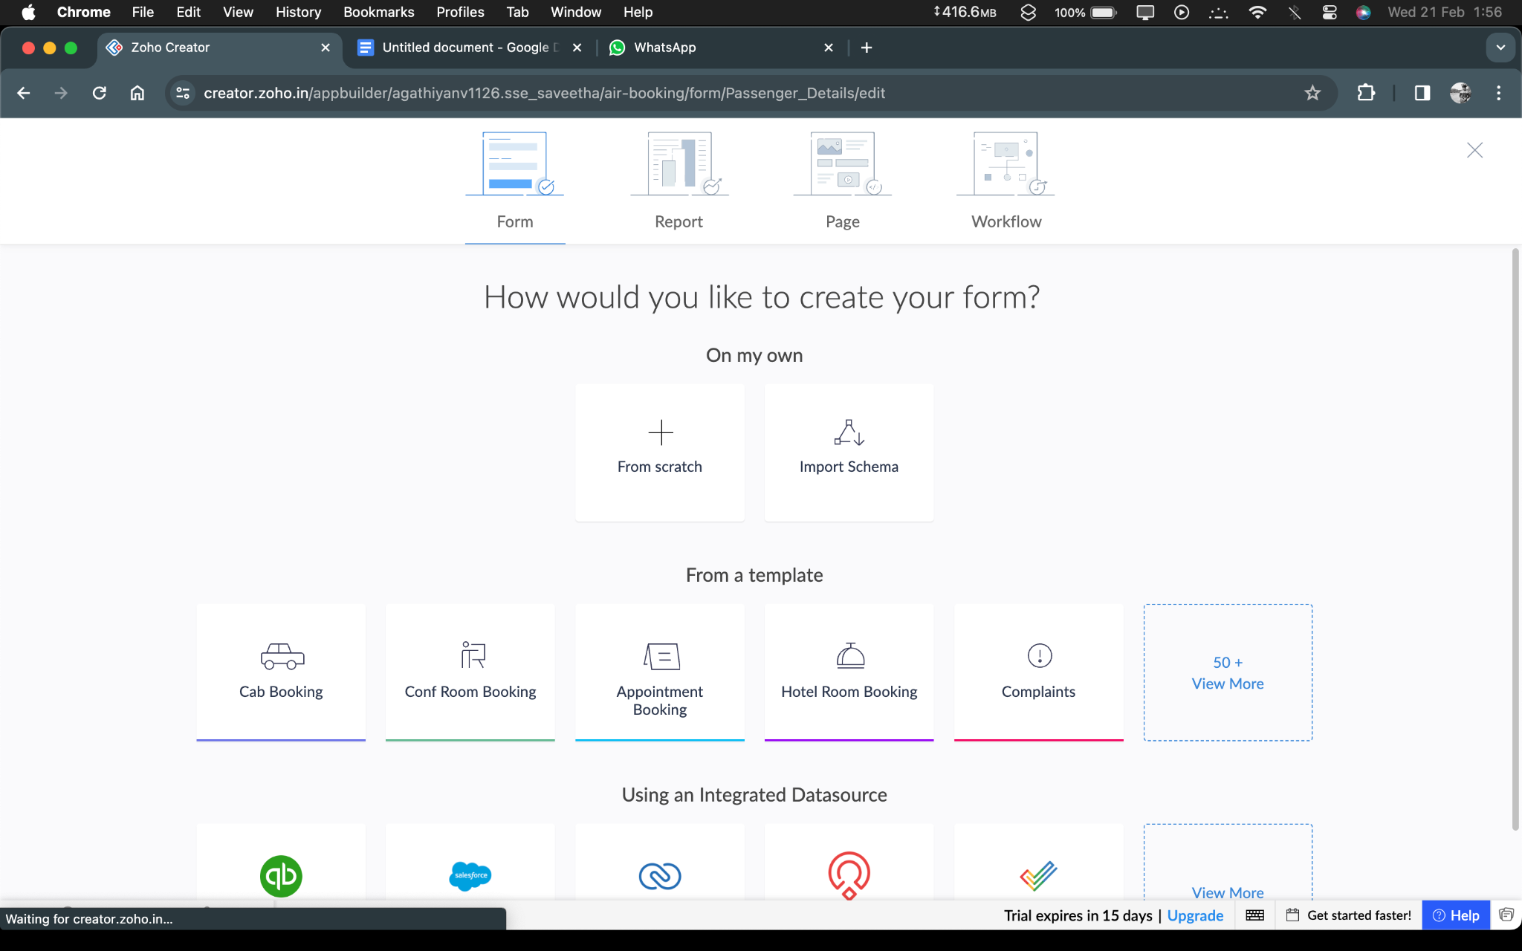

**STEP 03:** To Give a Name For Your Form and click a Button Create From Scratch

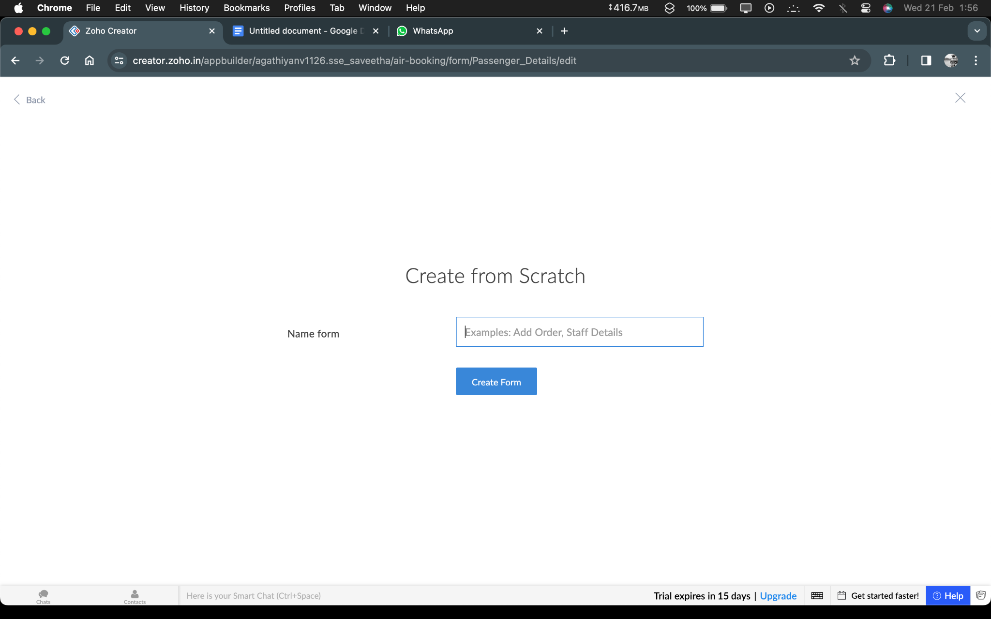

**STEP 04:** Create a login Form and Edit your form

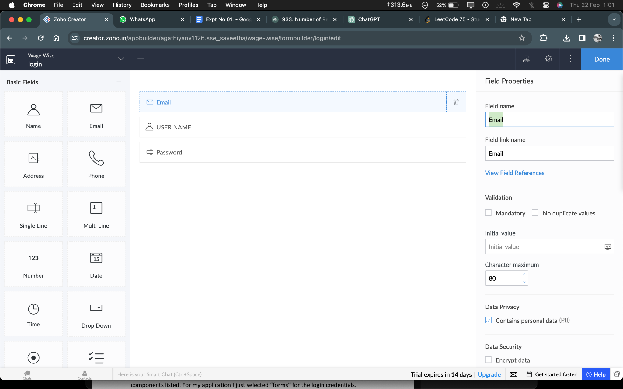

**STEP 05:** After Finish the Edit Process click Done And then Open the View page.

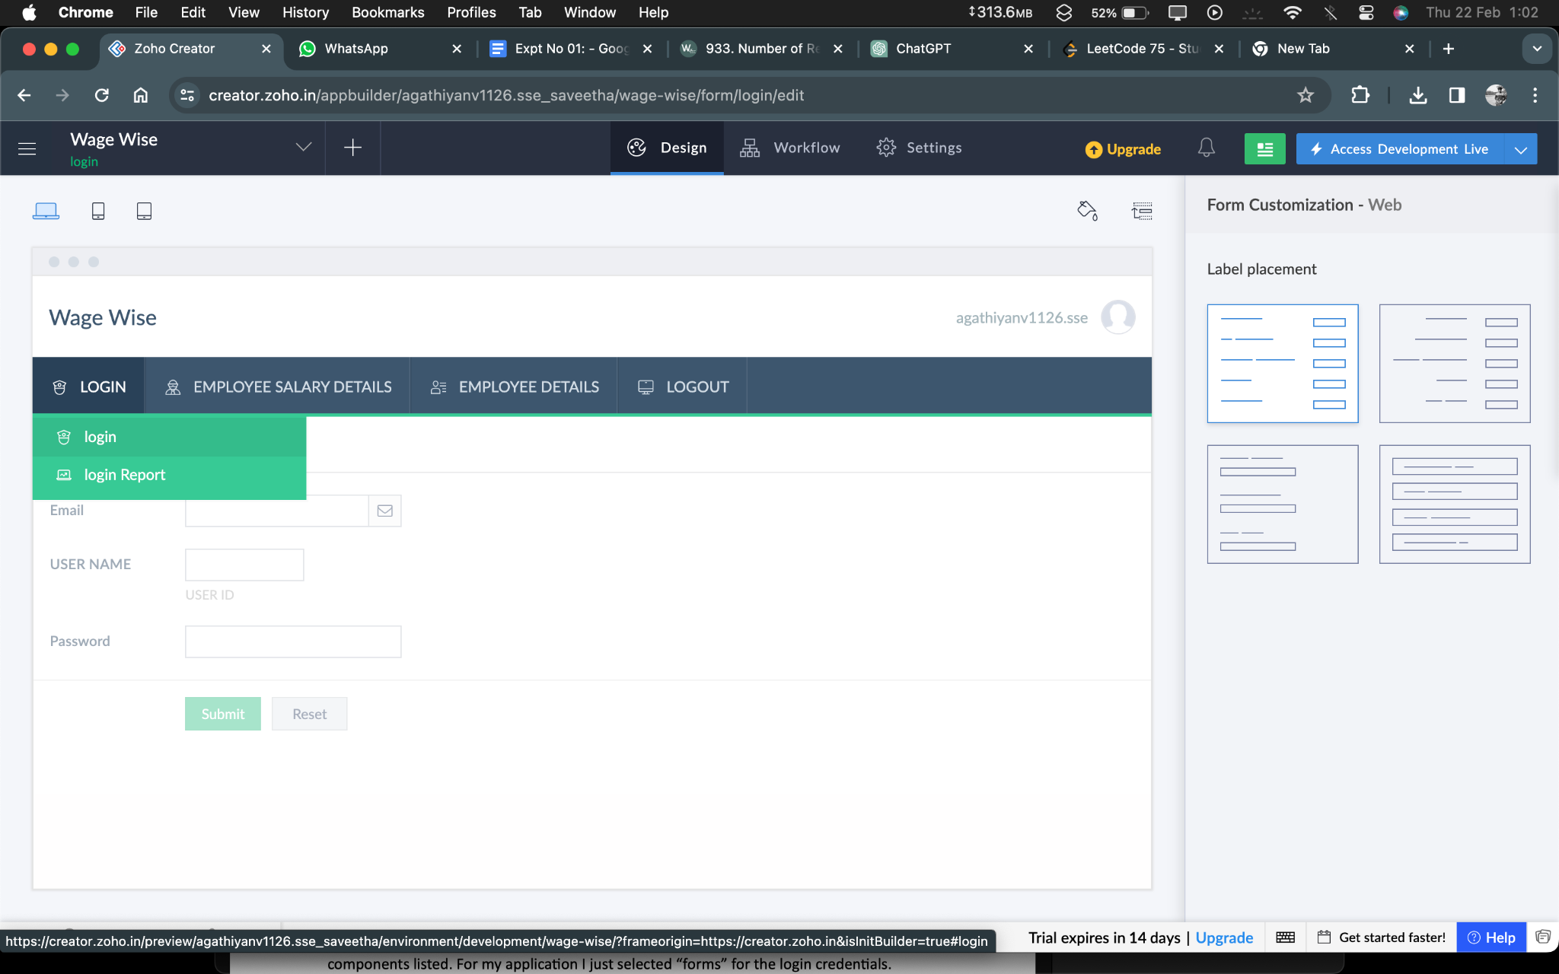

**STEP 06:** After Finishing that Create another form for your application by clicking a Add icon and Edit that form.

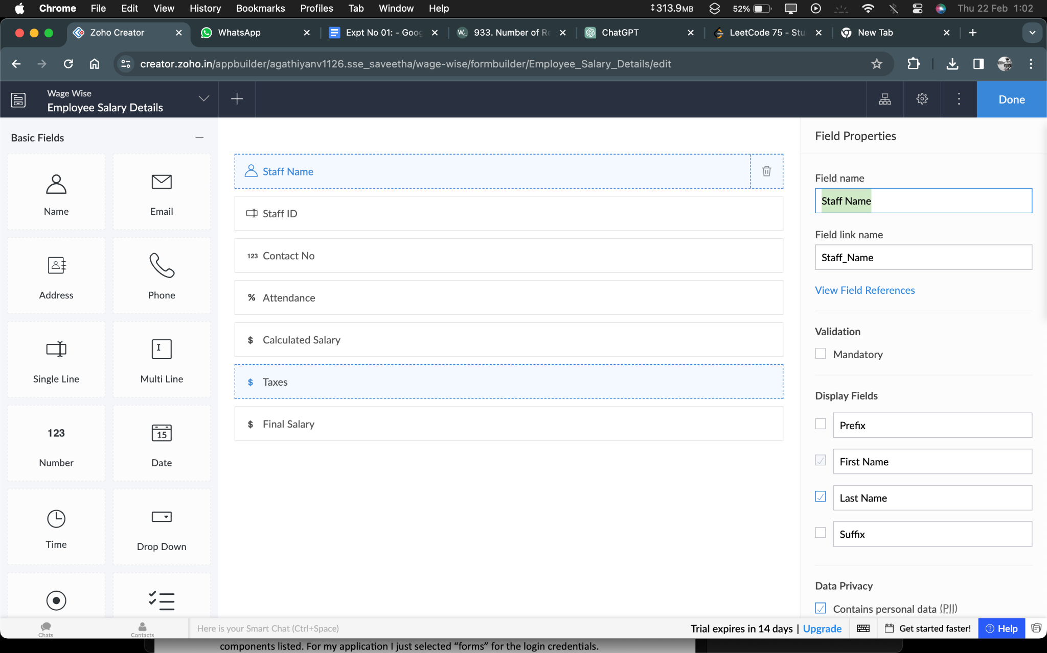

**STEP 07:** After Finish the Edit Process click Done And then Open the View page.

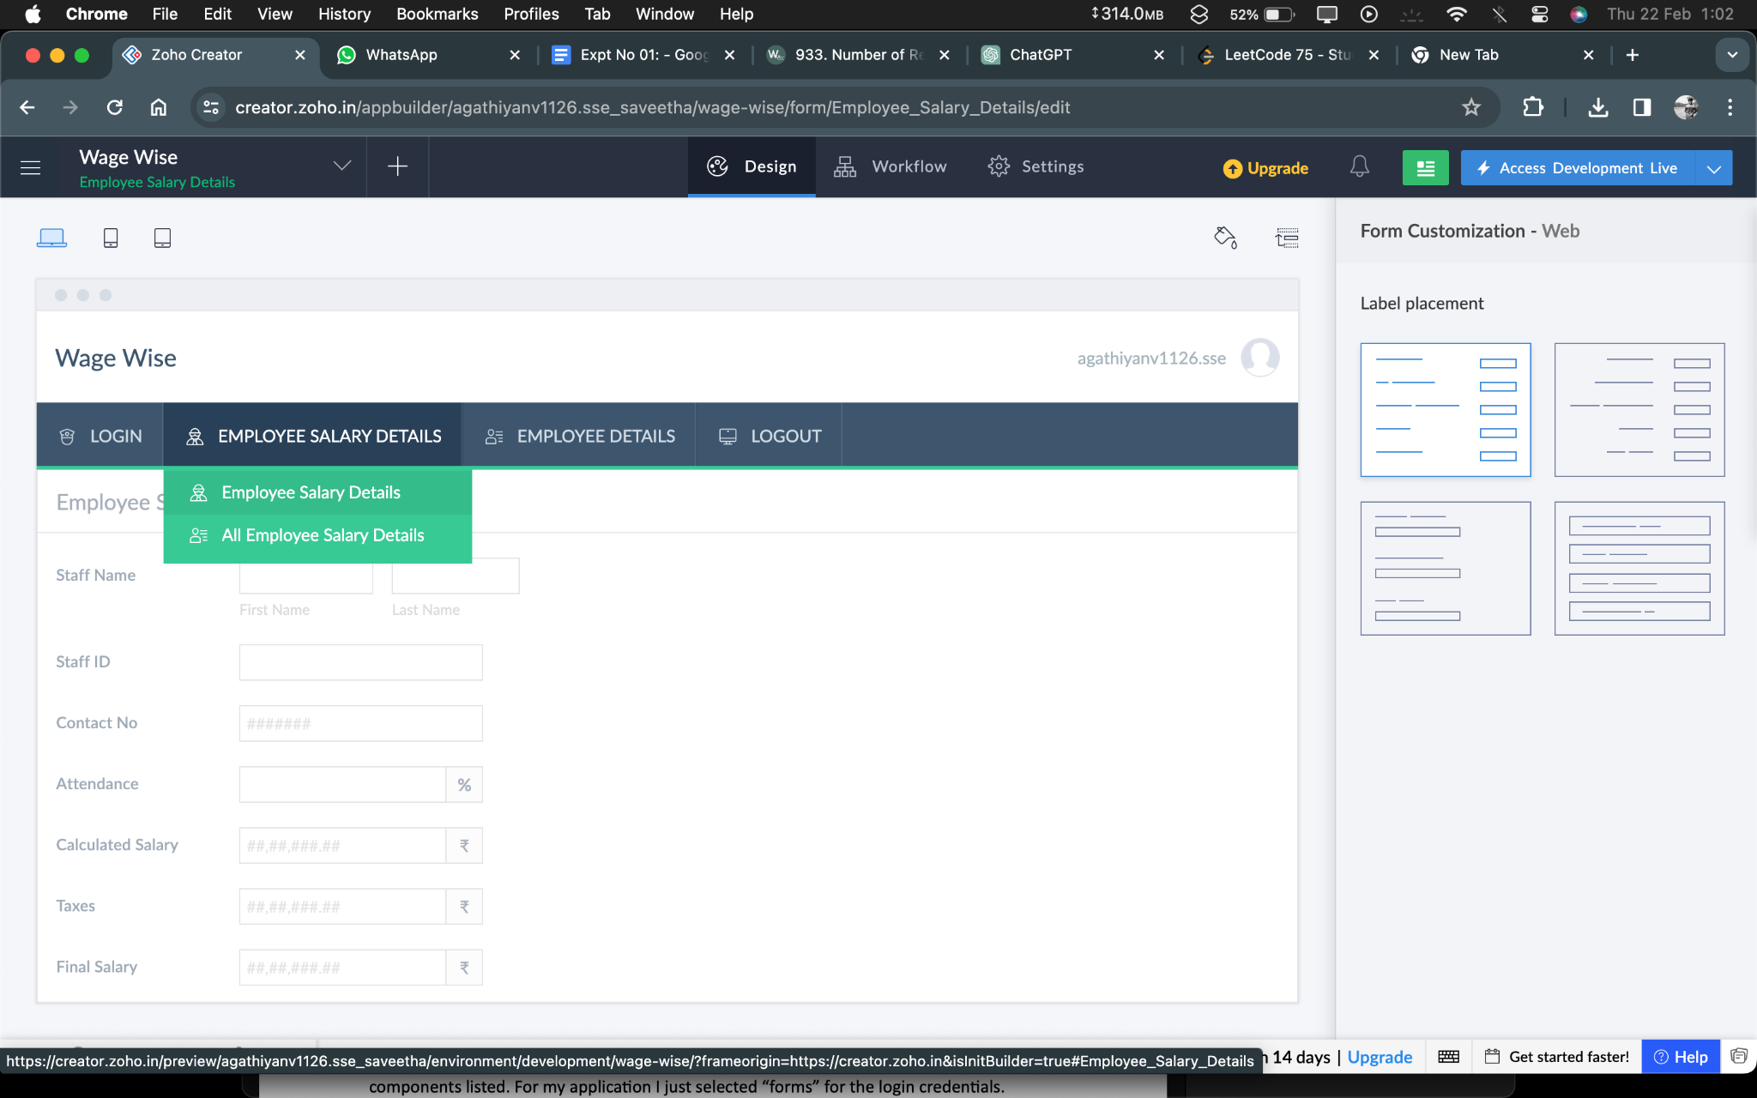

**STEP 08 :** After Finishing that Create another form for your application by clicking a Add icon and Edit that form.

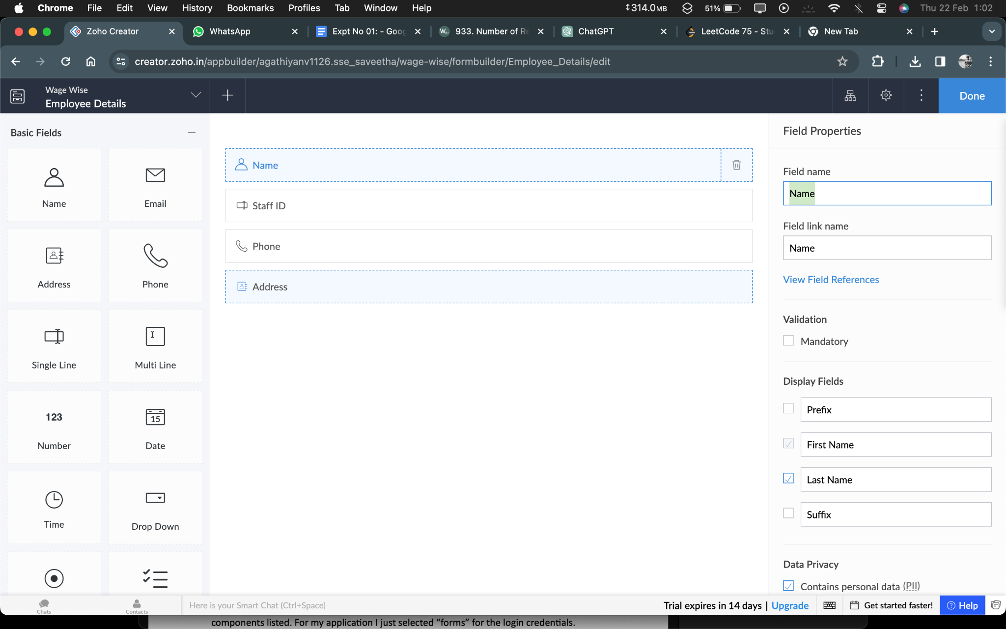

**STEP 09:** After Finish the Edit Process click Done And then Open the View page.

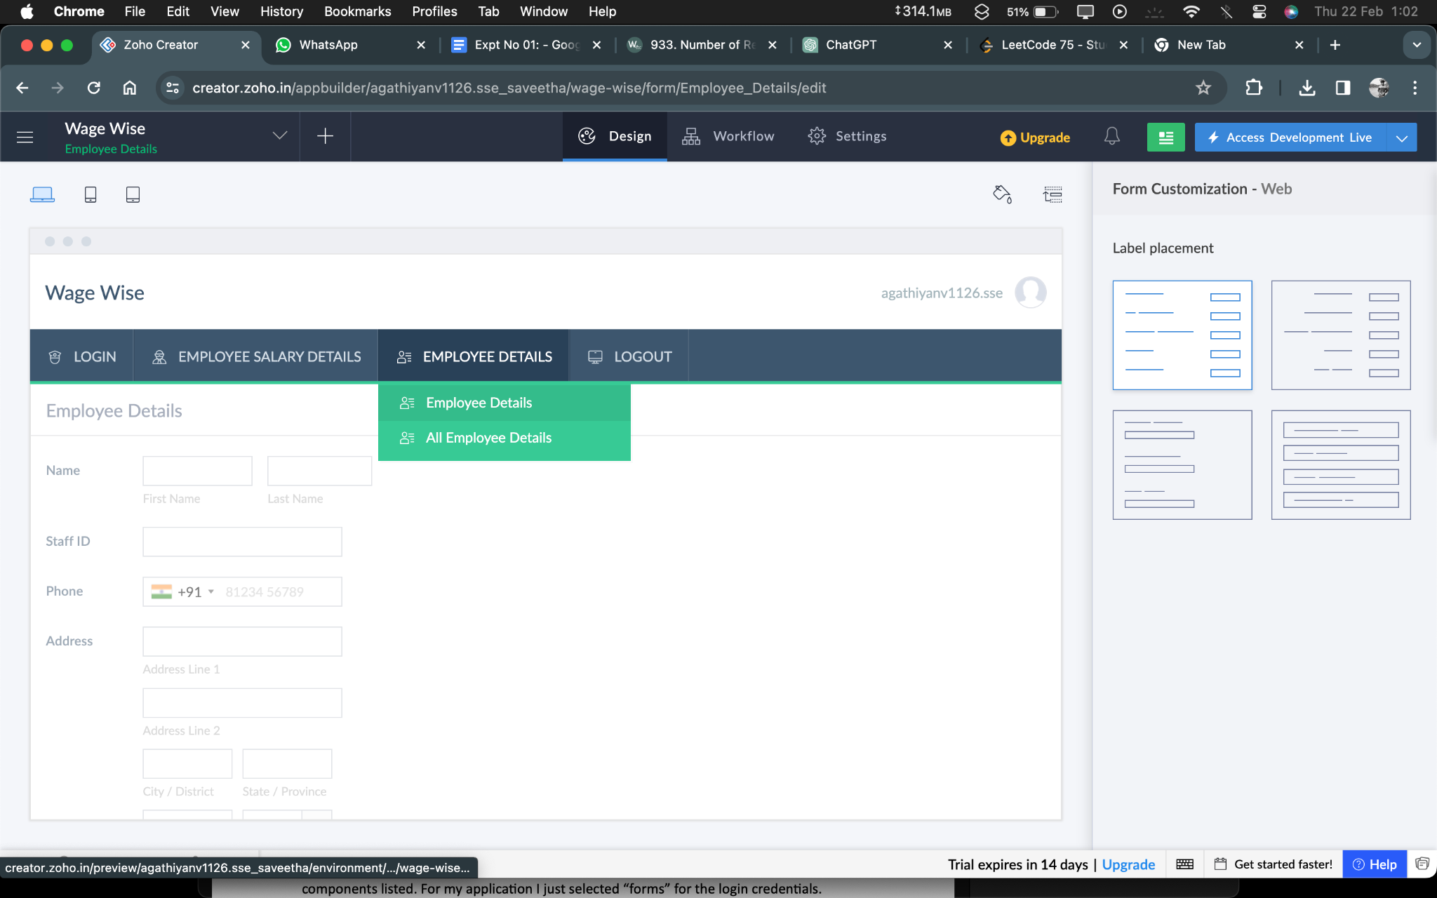

**STEP 10:** After Finishing that Create another form for your application by clicking a Add icon and Edit that form.

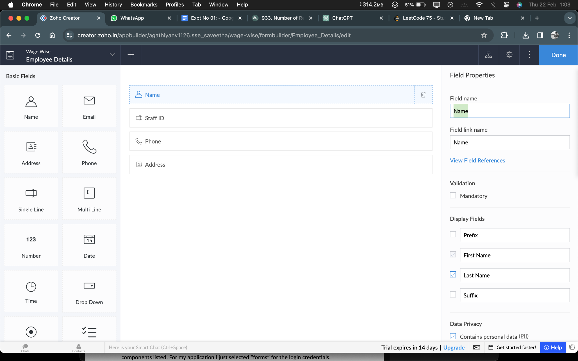

**STEP 11:** After Finish the Edit Process click Done And then Open the View page.

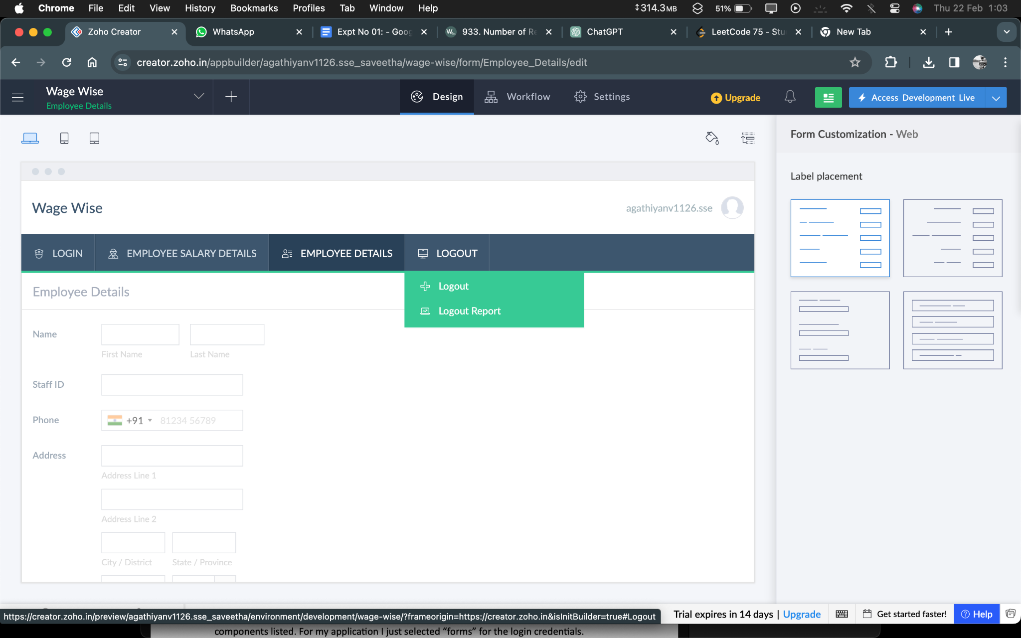

**STEP 12:** After Finishing that Create another form for your application by clicking a Add icon and Edit that form.

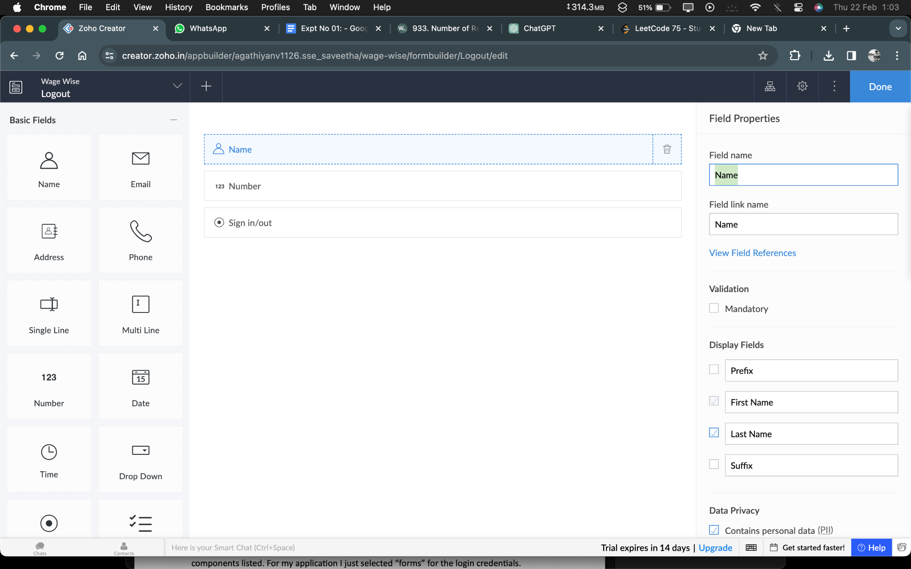

**STEP 13:** After Finish the Edit Process click Done And then Open the View page.

